Zach Bryan’s anti-ICE song drew ire from Trump officials. Is country music waking up?
Emerging stars are starting to critique Trump’s immigration crackdown – defying the genre’s legacy of conservatism
Justin Kirkland Thu 22 Jan 2026 https://www.theguardian.com/music/2026/jan/22/trump-ice-immigration-country-music
Thanksgiving did not go the way that Frank Ray had anticipated.
The country singer had invited his family up from Texas to Tennessee for the holiday, with plans to deep-fry a turkey, explore Nashville, and take in a show at the Grand Ole Opry. But on Thanksgiving morning, Ray received an unsettling call: TSA had flagged his sister’s husband, Juan Nevarez-Porras, at El Paso international airport due to insufficient documentation required to fly.
Born in Mexico, Nevarez-Porras has lived in the United States for 20 years, is a green-card applicant, and recently received a renewed five-year work authorization – which is still listed as an acceptable travel document, according to the TSA. ICE detained him shortly after, while his son, who is 16 years old and a US citizen, was taken into the custody of border patrol. In Tennessee, Ray’s family was at a loss as to how to remedy the situation.
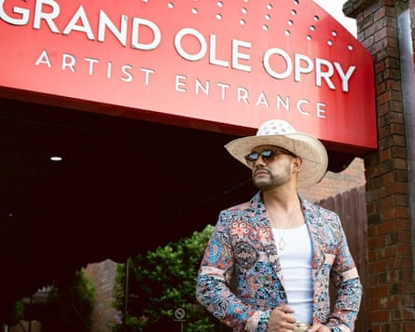
Frank Ray. Photograph: Ari Lyon
As the US immigration crackdown continues, stories like Ray’s have become disturbingly familiar. They also have all the makings of a country song: snapshots of American hardship and heartbreak, of working men and women whose oppression is laid bare by guitar and melancholy melody. Decades ago, Merle Haggard’s The Immigrant and Dolly Parton’s cover of Woody Guthrie’s Deportee advocated for the rights of Mexican immigrants in America. Ray himself waded into the topic of immigration in 2023 with Jesus at the Taco Truck, written and performed with Shy Carter, about a man named Jesus with scars on his feet and hands from crossing the Rio Grande.
Did you hear it on the radio? Probably not. That’s because anything considered mainstream in the genre shies away from social commentary that doesn’t pass the sniff test of conservatism. On the Billboard Top 20 for country music, heartbreak is served with a shot of tequila. Country’s most powerful names – Lainey Wilson and Ella Langley, Luke Combs and Morgan Wallen – make reference to Texas but shirk addressing the immigrant experience there. (Ironically enough, the only politically tinged song charting right now is Cody Johnson’s cover of the Chicks’ Travelin’ Soldier; more on them later.) For a genre that gestures at being the voice of Americana, country seems determined to ignore one of the biggest stories in America right now.
It’s like the Toby Keith-ification of country music
Bryan Andrews
This makes Zach Bryan’s recent foray into anti-ICE territory all the more interesting.
At a Bryan concert, you’ll find rough and tough blue-collar guys, as well as an army of young women, fervent as the Swiftie fanbase, screaming out lyrics about grief and loss and military service. Though largely shunned by country establishment, Bryan’s honest storytelling and Americana bona fides have struck a nerve: he recently broke a US concert attendance record previously held by George Strait, and his new album debuted at No 1 on the Billboard 200 chart this week.
In October, Bryan teased a verse off Bad News, singing that “ICE is gonna come bust down your door / Try to build a house no one builds no more,” to the ire of Trump administration officials. The homeland security secretary, Kristi Noem, told the rightwing podcast host Benny Johnson: “I hope he understands how completely disrespectful that song is not just to law enforcement, but to this country, to every single individual that has ever stood up and fought for our freedoms.” For context, Bryan served in the US navy for eight years.
Bryan answered by explaining in a post that the song “hits on both sides of the aisle”. He later added: “Left wing or right wing, we’re all one bird and American. To be clear, I’m on neither of these radical sides.” But this both-sides-ism felt incongruent with the song’s scathing message, heard in full for the first time on 9 January: law enforcement, ICE, and the onslaught of gun violence in America are contributing to the “fading of the red, white and blue”. (Bryan’s team declined an interview offer.)
This was a clear criticism of ICE raids and the fractured state of American communities, from a genre all but devoid of them. Was it enough to overcome the muffling effect of Bryan’s call for unity?
“For artists of his size, yeah,” said Bryan Andrews, an emerging Missouri-based country artist. “I mean, he might’ve lost some fans over it, but he put the song out anyway, so it’s not like he gave a fuck. I respect the hell out of him for doing it. I just wish he wouldn’t have followed it up the way he did.”
Andrews has gone viral for his TikTok tangents skewering Donald Trump, ICE and bigotry in a thick southern drawl – he calls them “crash outs” – and he has released politically charged songs that reference the Epstein files and wealth inequality. But he recalls a period when he felt it was more advantageous for his music career to stay quiet. Last year’s ICE raids changed that. “I was like, I have to write about this,” he said. “Whether you’re here legally or not, we still have to offer due process because we have a constitution.”
His message to the country genre now is: “Grow some fucking nuts.”

Bryan Andrews. Photograph: Claire Schmitt
“I’m sick and damn tired of watching people like Jason Aldean say stupid shit like, ‘If you don’t like it here, leave,’” Andrews said, referring to Aldean and his ilk’s protestations against woke-ism and outsiders. “It’s like the Toby Keith-ification of country music.” After 9/11, Keith helped popularize an onslaught of patriotic fervor, with singles such as American Soldier serving as propaganda for the war in the Middle East. In the years since, country has been littered with tracks like Aldean’s Try That in a Small Town about old ladies being carjacked and unnamed authorities rounding up people’s guns – a fearmongered mythology of a community coming together to protect itself from the monsters of sensationalist headlines.
“What I see in a small town [is] single moms who have to work two jobs because the corporations they work for don’t pay them enough to fucking be able to feed their children,” said Andrews. “I see farmers who fucking end up having to file for bankruptcy because they can’t afford the fucking trade war that Donald Trump has fucking put us in.”
In 2003, the Chicks’ lead singer Natalie Maines spoke against the war in Iraq and declared: “We’re ashamed that the president of the United States is from Texas.” The band became pariahs overnight. “Country artists saw what happened to them and went, ‘OK, I’m not doing anything controversial. I want to have a career,” said veteran journalist and country music historian Robert Oermann. “That has only intensified under the Trump administration … Popular culture is something that he cares about, and he wants to restrict it.”
Verified federal accounts have liberally used unlicensed music, including Bryan’s fan-favorite hit Revival, to soundtrack its anti-immigration propaganda. In doing so, the administration has run afoul of artists such as Sabrina Carpenter, Olivia Rodrigo, SZA and Jess Glynne, who have sniped back. But country’s legacy of outspokenness still rests on a select few. Like Tyler Childers, who seemed to stand in solidarity with immigrants when he performed Long Violent History – a song about racism, largely influenced by the Black Lives Matter movement – for the first time live at his Los Angeles concert after Trump’s deployment of national guard troops there. Or folk singer Jesse Welles, whose witty protest songs have gone viral a few times over, and who performed his pointed track Join ICE on The Late Show With Stephen Colbert in November (sample lyric: “If you’re lackin’ control and authority / Come with me and hunt down minorities / Join ICE”).
Oermann believes we have only started hearing timely immigration narratives play out in country song. “Today, the genre evolves faster because of the internet,” he said. “But to ask somebody to have an ICE song out already besides Jesse [Welles] is asking a lot.”
That might be setting the bar low for what was once music’s most in-the-know genre. Loretta Lynn’s The Pill was banned from radio in a time when radio was the main conduit to reaching fans. Keith’s Courtesy of the Red, White and Blue (The Angry American) debuted on the charts eight months after 9/11.
And, it took less than a year for Bryan to write and tease Bad News in response to the mass uptick in ICE raids kicked off by Trump’s second term.
In the immediate aftermath of his brother-in-law’s detention, Ray started making calls to arrange for his father to pick up his nephew. The exchange with a border patrol agent was tense. “We got into this little spat about policies and procedures, and then he wound up saying: ‘Hey, how about this? You want me to play the immigration card on your dad when he gets here?’” Ray’s father, also Mexican American, is an American citizen.
I feel like if you’re here and you’re hardworking, you’re contributing to society ... then you’re good enough to be here
Frank Ray
After Ray leveraged his social media platform to spread awareness of his brother-in-law’s story, the assistant DHS secretary Tricia McLaughlin issued a statement painting Nevarez-Porras as a criminal with a “rap sheet” that “includes battery, assault, criminal trespassing, and disorderly conduct”. Ray has acknowledged the instance of trespassing, but he maintains that the current system is one that “forgets that people are human”. While his nephew was reunited with the family, his brother-in-law remains in ICE custody in New Mexico.
Before switching to music full-time, Ray served 10 years as a law enforcement officer. He says the identities he holds – Mexican American, former police officer and country singer – are complicated, with people assuming his stances on immigration or law enforcement before he can vocalize them.

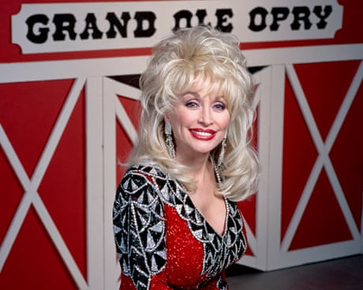
Urban cowboys, harmonica wizards and queer trailblazers: 100 years of the Grand Ole Opry, country music’s greatest institution
Read more

For instance, he won’t go so far as to call for the dismantling of ICE. “I believe you can have problems with particular ICE agents or you can have problems with particular border patrol agents, the same way you can be pro-law enforcement but have a particular issue with a particular law enforcement officer,” he said. His pride in law enforcement will be on display in his upcoming single Hard to Be a Hero, which is about “what we consider to be traditional country music values … pro-law enforcement and pro-America and pro-God and Jesus”, Ray said. “Those are things I genuinely believe.”
But his family’s run-in with immigration enforcement leaves him feeling frustrated. “I feel like if you’re here and you’re hardworking, you’re contributing to society, and if the government feels like you’re good enough to be taxed and they’ll take your money for it,” Ray said, “then you’re good enough to be here.”

