1 - Gregory Bovino, l’inconnu devenu symbole de la lutte contre l’immigration illégale menée aux États-Unis par Donald Trump
https://www.lefigaro.fr/international/gregory-bovino-l-inconnu-devenu-symbole-de-la-lutte-contre-l-immigration-illegale-menee-aux-etats-unis-par-donald-trump-20260121
... Environ 14 millions de personnes - le nombre de sans papiers vivant aux États-Unis selon les données de 2023 - sont dans le viseur du président des États-Unis, qui veut en expulser 30.000 par jour, un million par an. Pour atteindre ses objectifs, le locataire de la Maison-Blanche a considérablement renforcé les moyens de son administration à l’aune d’une réforme fiscale qui a débloqué 170 milliards de dollars (145 milliards d’euros) supplémentaires. Forte de 10.000 agents à terme, le budget de l’ICE s’élève à 75 milliards, une enveloppe trois fois plus importante qu’en 2024.
..
Ainsi de ce montage vidéo publié en mai 2025 où sa patrouille d’El Centro est représentée par le personnage de Star Wars Dark Vador combattant à coups de sabre laser es ennemis principaux de Donald Trump : les villes sanctuaires démocrates, le fentanyl, les fausses informations ou encore les trafiquants de drogue. La mission de Gregory Bovino est loin de se terminer. «Nous sommes là pour rester des années», a-t-il déclaré en décembre 2025. «Nous ne partirons pas tant que le problème ne sera pas résolu», abonde de son côté le département de la Sécurité intérieure sur X.
https://x.com/i/flow/login?redirect_after_login=%2Fhashtag%2FBorderPatrol%3Fref_src%3Dtwsrc%255Etfw%257Ctwcamp%255Etweetembed%257Ctwterm%255E1919023147942301778%257Ctwgr%255E897b41cafb7c5cc9e8b5aaa88b70abdbe827d87c%257Ctwcon%255Es1_%26ref_url%3Dhttps%253A%252F%252Fwww.lefigaro.fr%252Finternational%252Fgregory-bovino-l-inconnu-devenu-symbole-de-la-lutte-contre-l-immigration-illegale-menee-aux-etats-unis-par-donald-trump-20260121%26src%3Dhashtag_click

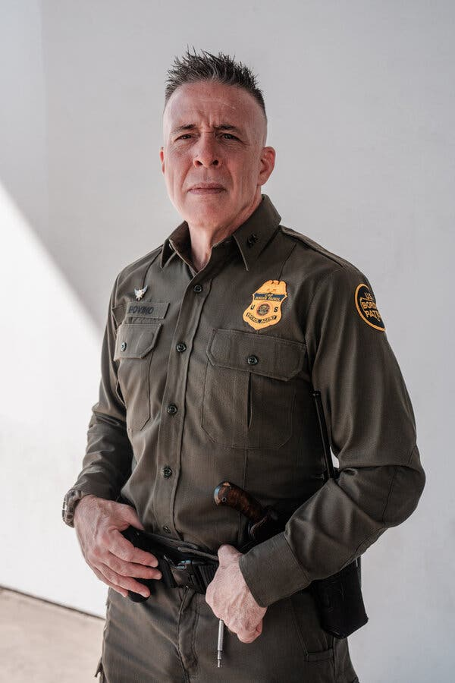
2_ The Border Patrol Chief Leading the California Immigration Crackdown Aug. 29, 2025 By Hamed Aleaziz and Jesus Jiménez
https://www.nytimes.com/2025/08/29/us/gregory-bovino-immigration-california.html

Earlier this summer, Gregory Bovino, 55, was named the tactical commander in charge of immigration enforcement operations in the Los Angeles area.Credit...Gabriela Bhaskar/The New York Times

Gregory Bovino has orchestrated thousands of arrests, using confrontational tactics that have made him a MAGA star. His critics say he’s crossing legal and political lines.
Earlier this summer, Gregory Bovino, 55, was named the tactical commander in charge of immigration enforcement operations in the Los Angeles area.Credit...Gabriela Bhaskar/The New York Times
Listen to this article · 13:57 min Learn more
Hamed Aleaziz covers the Department of Homeland Security. Jesus Jiménez has been covering the L.A. raids since the operation began June 6.
Gregory Bovino, the Border Patrol chief leading the Southern California immigration crackdown that has stirred outrage and won the admiration of President Trump, said he had been told by federal officials to be on standby.
He may be tapped to recreate his aggressive Los Angeles raids in other American cities.
“I’ve definitely received direction to be ready in the event that they want me to go,” Mr. Bovino said.
Mr. Bovino, 55, is the face of the Trump administration’s campaign to round up, detain and deport thousands of undocumented immigrants in the nation’s second-largest city. In just 11 weeks, he has gone from being the little-known head of one of the least busy sectors on America’s Southern border to the tactical commander of a contentious multiagency federal operation.
He has been testing the limits of politicized law enforcement, clashing on social media with California Democrats and producing Hollywood-style promotional videos of his masked, heavily armed officers marching to Kendrick Lamar’s “DNA.” He questioned an Army general’s loyalty to the country when the general expressed reservations about the National Guard’s involvement in one show of force at a Los Angeles park, according to court testimony. And he’s a named defendant in two lawsuits accusing his agents of crossing legal lines, including arresting Latino residents based on their skin color and regardless of their immigration status.
Mr. Bovino’s supporters say he’s helping to pull undocumented immigrants with violent criminal records off the streets. One of the biggest fans of his work is Mr. Trump. “The president called into the entire team that was assembled just to say, ‘Thank you, and you’re doing a good job in Los Angeles,’” Mr. Bovino said of a recent call with Mr. Trump.
His critics have a sharply different view, describing him as a showboat with a badge and a gun whose agents are using racial profiling to scoop up Hispanic men, women and teenagers. Outside of the federal takeover of the police force in the nation’s capital, no other region in America has seen such an aggressive display of federal force.
Two immigrants have died while trying to flee Mr. Bovino’s agents — a Mexican farmworker fell from a greenhouse, and a Guatemalan day laborer was struck by a vehicle on a freeway following a raid at a Home Depot.

Image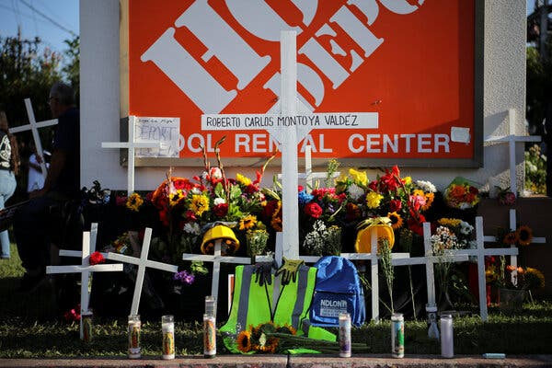
A temporary shrine at the entrance of a Home Depot, where a federal immigration raid took place this month in Monrovia, Calif. A day laborer fled, ran onto a freeway and was struck and killed by a vehicle.Credit...Daniel Cole/Reuters
Mr. Bovino’s agents opened fire on a vehicle that they tried to stop and that they claimed tried to hit them. They detained a disabled 15-year-old high school student, drawing their guns on him and handcuffing him in a case of mistaken identity, and leaving unfired bullets on the ground, school officials said. They have been captured on social-media videos smashing the windows of drivers who refuse to cooperate, questioning and detaining not only undocumented immigrants but also U.S. citizens and, in one case, urinating on storage containers on a high school campus.
And led by Mr. Bovino, they were involved this summer in two high-profile episodes that drew swift backlash from local officials.
Two weeks ago, Mr. Bovino and other agents showed up outside a museum in Los Angeles where Gov. Gavin Newsom was holding a rally. The event had nothing to do with immigration enforcement, but was focused instead on redistricting.
“We’re here making Los Angeles a safer place, since we don’t have politicians who can do that,” Mr. Bovino said as he stood next to his agents, some of whom carried rifles. “We do that ourselves.”
And last month, Mr. Bovino and dozens of federal agents marched through MacArthur Park, backed up by National Guard troops, helicopters and riot-ready horses. Mayor Karen Bass of Los Angeles suddenly showed up demanding answers, but the two officials did not meet face-to-face and talked by phone instead.
“I was on scene there,” Mr. Bovino later told the Fox affiliate in Los Angeles. “I was about 60 yards away from Mayor Bass. She didn’t want to come over and talk to me. She wanted to talk on the phone there.”
A spokeswoman for Ms. Bass said the mayor and Mr. Bovino spoke over the phone because he was not “immediately present” during the “military stunt.”
No arrests were made in the operation.
“It’s pretty unheard-of in any professional law enforcement organization to pull that stunt at MacArthur Park,” said Gil Kerlikowske, who served in the Obama administration as the commissioner of the Border Patrol’s parent agency, Customs and Border Protection. “If I was a commissioner at this point, I would have relieved him of duty after MacArthur Park.”
In two interviews with The New York Times, Mr. Bovino defended his operations in Los Angeles, calling them “legal, ethical and moral.” Mr. Bovino has said that agents have been targeting immigrants with criminal histories, but that any undocumented immigrant they come across could face arrest.
“And you may say, ‘Well, hey, don’t you feel bad?’ Well, no, I don’t,” Mr. Bovino said. “I’m not trying to be callous here, but it’s because we are giving them an out.” That out, he added, is the Trump administration’s announcement in May that it was offering $1,000 and a flight home to any undocumented immigrant who self-deports. He pointed out that one of his relatives used to live next door to an undocumented immigrant who was a drug trafficker.
“We got him deported, like, immediately,” Mr. Bovino said.
He said he had showed up outside the museum, not knowing that Mr. Newsom was holding a rally there. The museum is about a block away from a federal detention facility where many of those detained in raids have been held.
“He came to our neighborhood, a place that we work in and out of every single day, and we arrest illegal aliens every single day and bring them right into that facility,” Mr. Bovino said. “I didn’t know he was inside the building until a police officer said, ‘Hey, the governor’s supposed to be here.’”
Mr. Newsom called the presence of federal agents outside “pretty sick and pathetic,” and he and other Democratic leaders disputed that it was a mere coincidence. Mr. Newsom’s office filed a formal request seeking all documents about the decision to show up outside the rally.
Though Mr. Bovino said he harbored no ill will toward the governor, he criticized Mr. Newsom for failing to respond to a request to meet with agency officials in Mr. Bovino’s border region, the El Centro sector, back in 2023. “So he ignored me,” Mr. Bovino said. “Didn’t want to talk. I guess I was beneath him. That’s sure what it felt like.”
Izzy Gardon, a spokesman for the governor, did not directly respond to a question about Mr. Bovino’s meeting request. But he said that Mr. Newsom had visited the border frequently and “doesn’t need a hall pass” from Mr. Bovino to do so.
Sector chiefs oversee day-to-day operations in their regions, and they are typically focused on their A.O.R., agency parlance for area of responsibility. Silvestre Reyes used his experience as a sector chief in El Paso to win a seat in Congress in the 1990s. Most sector chiefs, however, do not venture into the world of politics and avoid antagonizing their region’s elected officials, with whom they usually build partnerships.
Although he has described himself as “apolitical,” Mr. Bovino has taken a different approach and has adopted a distinctly partisan edge. His remarks in interviews, his social-media posts and the videos that his team creates often criticize or ridicule Mr. Newsom, Ms. Bass and Democratic-run California as a whole.
“I see a lot of outrage from the governor when he talks about these ICE raids,” Mr. Bovino said of Mr. Newsom on Fox News. “Where is the outrage when there are Tren de Aragua members walking with impunity on the streets of Los Angeles?”
One “Star Wars”-themed video posted by Mr. Bovino depicted his sector as Darth Vader’s lightsaber. The rebel troops Darth Vader slaughters are portrayed as Sanctuary Cities, Fake News and Human Smugglers, among others.
Another video opens with comments Ms. Bass made following a raid known as Operation Trojan Horse. As the mayor says the border operation failed, the video quickly cuts to show Mr. Bovino cracking a smile, and then supplies the Border Patrol’s response to Ms. Bass. Rap music blares as his agents jump out of a Penske rental truck and chase down immigrants outside a Home Depot. The video ends with Mr. Bovino, wearing a tactical helmet, walking across the parking lot in slow motion, like a triumphant scene out of an action movie.
“It’s just far too political,” said Mr. Kerlikowske, the former Customs and Border Protection commissioner. “I mean, I don’t think you can find any of the Border Patrol chiefs, any of the ICE chiefs in the past, making these kinds of statements or taking these kinds of actions.”
Mr. Bovino said he saw his approach not as political, but as defending his agents from being attacked by lawmakers.
“When you have politicians that are encouraging MS-13 gang members to take action against law enforcement, then you’re damn right I’m going to say something,” he said.
He was referring to a local elected official who posted a video urging the leaders of street gangs to “get your members in order” in response to the raids and wondering why, “now that your ‘hood is being invaded by the biggest gang there is, there ain’t a peep out of you.” That official, Cynthia Gonzalez, the vice mayor of Cudahy, a small city in Los Angeles County, later said in public remarks that the video was satirical and had nothing to do with violence.
Mr. Bovino sent an early signal that he was ready to lead the administration’s immigration crackdown before Mr. Trump was even president.
On Jan. 6, in the last days of the Biden administration, Mr. Bovino led Operation Return to Sender, a raid in agricultural Kern County. At least 78 people, including farmworkers, were arrested. During that operation, agents fanned out across the area, at gas stations and along farm roads.
The American Civil Liberties Union sued the federal government over the raid on behalf of the United Farm Workers union, arguing that people were stopped based on unlawful factors such as the color of their skin. In April, a federal judge issued a preliminary injunction barring Border Patrol agents from stopping people in the Kern County area without reasonable suspicion that they are in the country illegally.
That pre-Trump raid in January was a kind of test run of the Los Angeles raids that started later in the year — high-profile sweeps in multiple locations at once to capture undocumented immigrants as they went about their daily routines. The L.A. raids started on June 6, and Mr. Bovino was named the operation’s tactical commander about a week later. Since the raids began, federal agents have made 5,000 arrests in the Los Angeles area, according to the Department of Homeland Security.
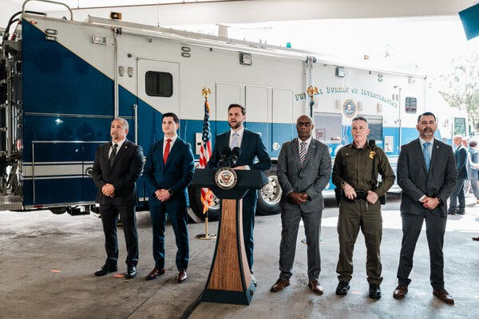
Mr. Bovino stands, second from right, with other officials as Vice President JD Vance talks to reporters in June. Credit...Gabriela Bhaskar/The New York Times
“Chief Bovino is an asset to the Trump Administration and playing an important role in Making America Safe Again,” Abigail Jackson, a White House spokeswoman, said in a statement.
In his spare time, Mr. Bovino has been flipping through a classic novel from the 1800s, “The Count of Monte Cristo,” the epic of wrongful imprisonment and revenge. He considers bear hunting one of life’s pleasures, and got his start in law enforcement working as a reserve police officer in the Blue Ridge Mountains in North Carolina, his home state. Federal officials declined to supply some biographical details about him, including his marital status or how many children he has, citing security threats.
Mr. Bovino attended Appalachian State University in Boone, N.C., for graduate school, and joined the Border Patrol when he was in his 20s, inspired by authors who wrote about their work as agents. He joined the agency in 1996 as a member of Border Patrol Academy Class 325.
“People underestimate his intelligence because of his demeanor sometimes, but he’s exceptionally smart,” said Jason Owens, a former Border Patrol chief who is a friend of Mr. Bovino and was also part of Academy Class 325. “He just has the country-boy demeanor, where he talks about Ma and Pa America, and his accent, and so a lot of people can dismiss him. They do that at their own peril.”
The Los Angeles raids have continued in recent days, despite legal developments that have made local officials and activists question whether agents were violating court orders. A federal judge issued a temporary restraining order barring federal agents from making indiscriminate stops in the Los Angeles area. An appeals court later upheld that ruling.
“They are not trying to follow the law,” said Mayra Joachín, a lawyer for the A.C.L.U. involved in both the Kern County and Los Angeles lawsuits. “They are not trying to avoid using race to stop someone.”
Mr. Bovino has pushed back on such accusations, noting that undocumented immigrants of various nationalities have been arrested and that a large percentage of Border Patrol agents are Hispanic.
“That’s agenda-driven talk by those trying to sow fear in people,” he said of racial-profiling claims.
It remains unclear how long Mr. Bovino will run operations in Los Angeles. But he said he had been told to be ready “to take on criminals at a moment’s notice in other locations.” The Department of Homeland Security did not comment on whether Mr. Bovino would be going to other cities.
Later this fall, he said, he would like to get back to North Carolina for bear-hunting season. “But I have a feeling that I may be continuing to make America a safer place,” he said, “and that always takes precedence over anything personal.”
Kitty Bennett contributed research.
Hamed Aleaziz covers the Department of Homeland Security and immigration policy for The Times.
Jesus Jiménez is a Times reporter covering Southern California.

3 - CBS. Border Patrol's Bovino says Minneapolis immigration operations "are not political". Jan 21st
- https://www.cbsnews.com/video/border-patrol-chief-bovino-minneapolis-immigration-operations-not-political/ VIDEO **

[Speaker 3] (0:08 - 0:18)  Let's move over to Minnesota now, where moments ago, Border Patrol Chief Gregory Bovino just spoke about federal immigration agents' operation in that state. Take a listen.  [Speaker 2] (0:19 - 1:03)  Now, folks, let me be clear from the start that public safety in Minneapolis is not negotiable. When violent criminals exploit gaps in enforcement, gaps at that state and local level most especially, federal law enforcement has a responsibility to act. That is why we are here, and that is what this operation is about.  Our operations are lawful, they're targeted, and they're focused on individuals who pose a serious threat to this community. They are not random, and they are not political. They are about removing criminals who are actively harming Minneapolis neighbourhoods.  [Speaker 3] (1:04 - 1:13)  CBS News Homeland Security correspondent Nicole Skanga joins us live over the phone. Nicole, you just listened to Mr. Bovino's remarks. Can you break down what he said?  [Speaker 1] (1:13 - 3:17)  Yeah, Liz, we're in the room now. You heard Commander Bovino there talk about public safety, saying the presence here of more than 3,000 federal agents is non-negotiable. He called operations lawful and targeted, not random, not political.  Of course, we've heard other whys from local leaders here in the state of Minnesota, but he said that ICE and CBP are still actively removing residents, he said, that pose a threat to Minneapolis. He cited specific anecdotal instances of murderers, rapists, cartel members, though did not give an exact number as to how many of the total arrests here in Minneapolis. Which we know are now greater than 3,000, include those individuals who are criminal offenders.  He did mention that in the past year, there have been roughly 10,000 arrested, presumably for civil immigration violations in Minnesota. He also referenced the number of illegal crossings as dropping, saying what happens at the border doesn't stay in the border. We also did hear from Marcos Charles.  He is the executive associate director at ICE enforcement and removal operations here in Minneapolis. He encouraged the public to use ICE tip lines to report on potential public safety threats. He also called on local law enforcement.  He said that there are 1,360 individuals with detainers, presumably individuals who are in Minnesota's jails and prisons, that ICE would like. And he called on local law enforcement to comply. Of course, my follow-up question is, are those individuals who have final orders of removal, are those criminal offenders?  Unfortunately, we did not get to ask that question. But an interesting number there will be interesting to pose to local law enforcement, because right now, federal law enforcement is saying that if state and local police want ICE out of Minneapolis, all they need to do is cooperate with agents on the ground.  [Speaker 3] (3:18 - 3:25)  And, Nicole, you have some new reporting on the Justice Department's investigation into Minnesota state officials. What can you tell us about that?  [Speaker 1] (3:26 - 5:11)  Yeah, absolutely. The Justice Department today served subpoenas to multiple Democratic officials in Minnesota, Governor Tim Walz, Attorney General Keith Ellison, Minneapolis Mayor Jacob Frey, all in connection with an investigation into what they're calling an alleged conspiracy to impede federal immigration officers, according to sources familiar with the matter. Now, the subpoenas are a significant sort of escalation in this ongoing battle we've seen between the Justice Department and Minnesota officials who have really clashed amid the crackdown on illegal immigration in the state.  They were served those subpoenas today. We know that Attorney General Pam Bondi is on the ground in Minnesota visiting. They were sent in connection, again, with this wider investigation the Justice Department is doing into state and local officials to see if they might have conspired to impede federal officers from discharging their duty.  We have seen copies of this subpoena. We have been previously told that this investigation is based on 18 U.S.C. 372, which, interestingly enough, is the same provision of U.S. law that was used to charge many of those who stormed the U.S. Capitol on January 6, 2021, including far-right Oath Keepers and members of the Proud Boys remains to be seen whether or not these are even viable, whether or not we see charges in connection to these Democratic Minnesota lawmakers.  But we know that this probe is widening and deepening tensions between the federal government and the Department of Justice and Minnesota and Minneapolis lawmakers here.  ………. | [Intervenant 3]  Passons maintenant au Minnesota, où le chef de la police des frontières, Gregory Bovino, vient de s'exprimer sur les opérations des agents fédéraux de l'immigration dans cet État. Écoutons-le.  [Intervenant 2]  Écoutez, je tiens à être clair dès le départ : la sécurité publique à Minneapolis est non négociable. Lorsque des criminels violents exploitent les failles des forces de l’ordre, notamment au niveau étatique et local, il est de la responsabilité des autorités fédérales d’agir. C’est la raison de notre présence ici et l’objet de cette opération.  Nos opérations sont légales, ciblées et visent des individus qui représentent une menace sérieuse pour la communauté. Elles ne sont ni aléatoires ni politiques. Leur objectif est d'éliminer les criminels qui nuisent activement aux quartiers de Minneapolis.  [Intervenant 3]  Nicole Skanga, correspondante de CBS News pour la sécurité intérieure, est avec nous en direct par téléphone. Nicole, vous venez d'écouter l'intervention de M. Bovino. Pouvez-vous nous en résumer les points principaux ?  [Intervenant 1]  Oui, Liz, nous sommes dans la salle. Vous avez entendu le commandant Bovino parler de sécurité publique, affirmant que la présence de plus de 3 000 agents fédéraux était non négociable. Il a précisé que les opérations étaient légales et ciblées, et non aléatoires ou non politiques.  Bien sûr, nous avons entendu d'autres explications de la part des responsables locaux ici, dans l'État du Minnesota, mais il a affirmé que l'ICE et le CBP continuent d'expulser activement les résidents qui, selon lui, représentent une menace pour Minneapolis. Il a cité des exemples précis de meurtriers, de violeurs et de membres de cartels, sans toutefois préciser le nombre d'arrestations parmi les 3 000 arrestations effectuées à Minneapolis. On sait que ce nombre dépasse désormais les 3 000, et inclut les personnes ayant commis des infractions.  Il a mentionné qu'au cours de l'année écoulée, environ 10 000 personnes avaient été arrêtées, vraisemblablement pour des infractions à la législation sur l'immigration au Minnesota. Il a également fait état d'une baisse du nombre de passages illégaux, soulignant que ce qui se passe à la frontière ne reste pas à l'intérieur de celle-ci. Nous avons également entendu l'intervention de Marcos Charles.  Il est directeur adjoint exécutif des opérations d'application de la loi et d'expulsion de l'ICE à Minneapolis. Il a encouragé le public à utiliser les lignes téléphoniques de l'ICE pour signaler les menaces potentielles à la sécurité publique et a également appelé les forces de l'ordre locales à collaborer.  Il a déclaré que 1 360 personnes faisant l'objet d'un mandat d'arrêt, vraisemblablement incarcérées dans les prisons du Minnesota, étaient recherchées par l'ICE. Il a exhorté les forces de l'ordre locales à coopérer. Ma question est donc : ces personnes, visées par un ordre d'expulsion définitif, sont-elles des délinquants ?  Malheureusement, nous n'avons pas pu poser cette question. Mais un chiffre intéressant serait à soumettre aux forces de l'ordre locales, car actuellement, les autorités fédérales affirment que si la police d'État et locale souhaite le départ de l'ICE de Minneapolis, il leur suffit de coopérer avec les agents sur place.  Nicole, vous avez de nouvelles informations concernant l'enquête du ministère de la Justice sur les responsables de l'État du Minnesota. Que pouvez-vous nous dire à ce sujet ?  Oui, absolument. Le ministère de la Justice a signifié aujourd'hui des citations à comparaître à plusieurs responsables démocrates du Minnesota, au gouverneur Tim Walz, au procureur général Keith Ellison et au maire de Minneapolis Jacob Frey, dans le cadre d'une enquête sur ce qu'il qualifie de complot présumé visant à entraver le travail des agents fédéraux de l'immigration, selon des sources proches du dossier. Ces citations marquent une escalade significative dans le conflit qui oppose le ministère de la Justice aux autorités du Minnesota, déjà fortement opposées dans le contexte de la répression de l'immigration clandestine dans l'État.  Ces citations à comparaître leur ont été signifiées aujourd'hui. Nous savons que la procureure générale Pam Bondi est actuellement sur place, dans le Minnesota. Ces citations s'inscrivent dans le cadre de l'enquête plus vaste menée par le ministère de la Justice sur des responsables étatiques et locaux, afin de déterminer s'ils ont pu conspirer pour entraver le travail des agents fédéraux.  Nous avons vu des copies de cette assignation. On nous a précédemment indiqué que cette enquête se fonde sur l'article 372 du titre 18 du Code des États-Unis, qui, fait intéressant, est la même disposition du droit américain qui a servi à inculper nombre de ceux qui ont pris d'assaut le Capitole le 6 janvier 2021, notamment des membres du groupe d'extrême droite Oath Keepers et des Proud Boys. Il reste à voir si ces accusations sont fondées et si des poursuites seront engagées contre ces élus démocrates du Minnesota.  Mais nous savons que cette enquête ne fait qu'exacerber les tensions entre le gouvernement fédéral et le ministère de la Justice, d'une part, et les législateurs du Minnesota et de Minneapolis, d'autre part.

4- Who is Greg Bovino, the official in charge of Trump’s border patrol operations
Greg Bovino, the Border Patrol leader behind President Donald Trump’s aggressive immigration crackdown across the U.S., has risen in prominence in recent weeks after escalated enforcement and mass deportation initiatives.
Published 12:58 AM UTC+1, January 21, 2026 VIDEO 1’30 ***
https://apnews.com/video/who-is-greg-bovino-the-official-in-charge-of-trumps-border-patrol-operations-db230af71c53406c9c4741c635f3acf9

[Speaker 1] (0:00 - 1:26)  Greg Bovino has cut from a different cloth when it comes to U.S. immigration authorities. He relishes the spotlight. He has a very active presence on social media.  You see him wearing M4 assault rifles and full tactical gear, rap music playing in the background. He gets in public spats with officials who oppose the Trump administration's agenda. In a very short time, he's become a public face of the administration's efforts at mass deportation.  We saw him first in Los Angeles, where he assumed the title of Border Patrol Commander-at-Large. From there, he went to Chicago, he went to Charlotte, North Carolina, New Orleans, most recently in Minneapolis. He's been in just about all of the major confrontational scenes that we've witnessed, maybe not all, but a significant percentage.  He has been there on camera and enjoying it. In Chicago, just one example, a helicopter landed on the roof of an apartment building, agents rappelling down the side of it. He was there.  He was on Chicago's Michigan Avenue in the Chicago River. He's in the spotlight, in your face, and he makes no bones about it that the Border Patrol is taking the Border Patrol's more aggressive tactics that we see on the border and making them much more common and almost replacing ISIS's more methodical, targeted approach. He calls it turn and burn.  It's a system to get in quickly, make the arrest, rack them up, and get out before the protesters arrive. | [Intervenant 1]  Greg Bovino est un personnage à part parmi les autorités d'immigration américaines. Il adore être sous les feux des projecteurs et est très actif sur les réseaux sociaux.  On le voit armé de fusils d'assaut M4 et en tenue tactique complète, sur fond de rap. Il s'en prend publiquement aux responsables qui s'opposent à la politique de l'administration Trump. En très peu de temps, il est devenu le symbole des efforts de cette administration pour les expulsions massives.  Nous l'avons vu pour la première fois à Los Angeles, où il a pris le titre de commandant itinérant de la police des frontières. De là, il est allé à Chicago, puis à Charlotte (Caroline du Nord), à La Nouvelle-Orléans, et plus récemment à Minneapolis. Il a été présent dans presque toutes les scènes de confrontation majeures auxquelles nous avons assisté, peut-être pas toutes, mais dans une proportion significative.  Il était présent devant les caméras et semblait apprécier le spectacle. À Chicago, pour ne citer qu'un exemple, un hélicoptère a atterri sur le toit d'un immeuble, des agents descendant en rappel le long de la façade. Il était là.  Il se trouvait sur Michigan Avenue à Chicago, au bord de la rivière Chicago. Sous les projecteurs, il est omniprésent et il ne cache pas que la police des frontières généralise ses tactiques agressives, déjà observées à la frontière, au point de presque remplacer l'approche plus méthodique et ciblée de Daech. Il appelle ça « retourner et brûler ».  C'est un système qui permet d'entrer rapidement, de procéder aux arrestations, d'accumuler les détenus et de sortir avant l'arrivée des manifestants.

